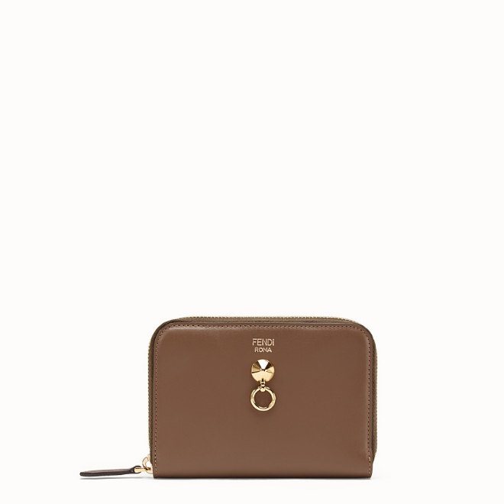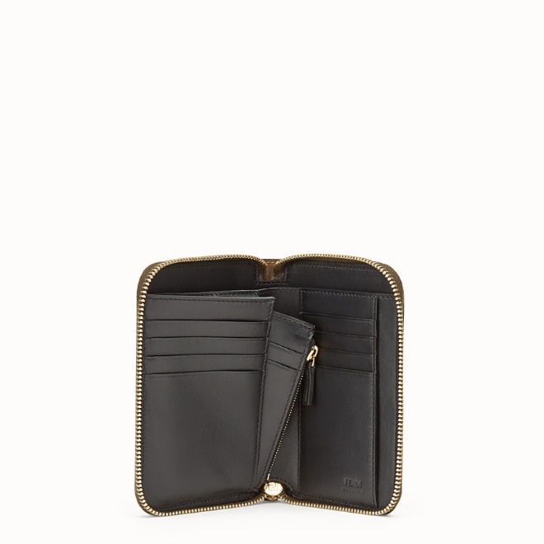

FENDI-ZIP-AROUND

$550.00

COLOR :Brown leather wallet  
SIZE : ONE SIZE  
IN STOCK

[Detail](http://127.0.0.1:60314/content/2O07vk1xAxKqC65AAAAg/f4WMa4c/gMQqTgF/z9XEqdq/fZzttge" \l "collapse)

By The Way wallet with zip fastening along three sides. Interior features a large bill compartment, 8 card holder slots and a removable coin pouch with zip fastening. Made of brown calfskin. Black leather interior and pouch. Decorated with the iconic By The Way stud. Gold-finish metalware.Made in Italy.

• Length:15

• Height:10,5

• Depth:2

• Composition:100% calf leather + inside: 100% calf leather + 50% cotton, 42% polyamide, 8% resins

Universal Style: Product Code:8M04016GMF13VK

More information? [Click here](http://127.0.0.1:60314/content/2O07vk1xAxKqC65AAAAg/f4WMa4c/gMQqTgF/z9XEqdq/Information/FENDI-CARD%20POUCH.docx)

[CARE & COMPOSITION](http://127.0.0.1:60314/content/2O07vk1xAxKqC65AAAAg/f4WMa4c/gMQqTgF/z9XEqdq/fZzttge#collapse1)

• Leather

• Imported